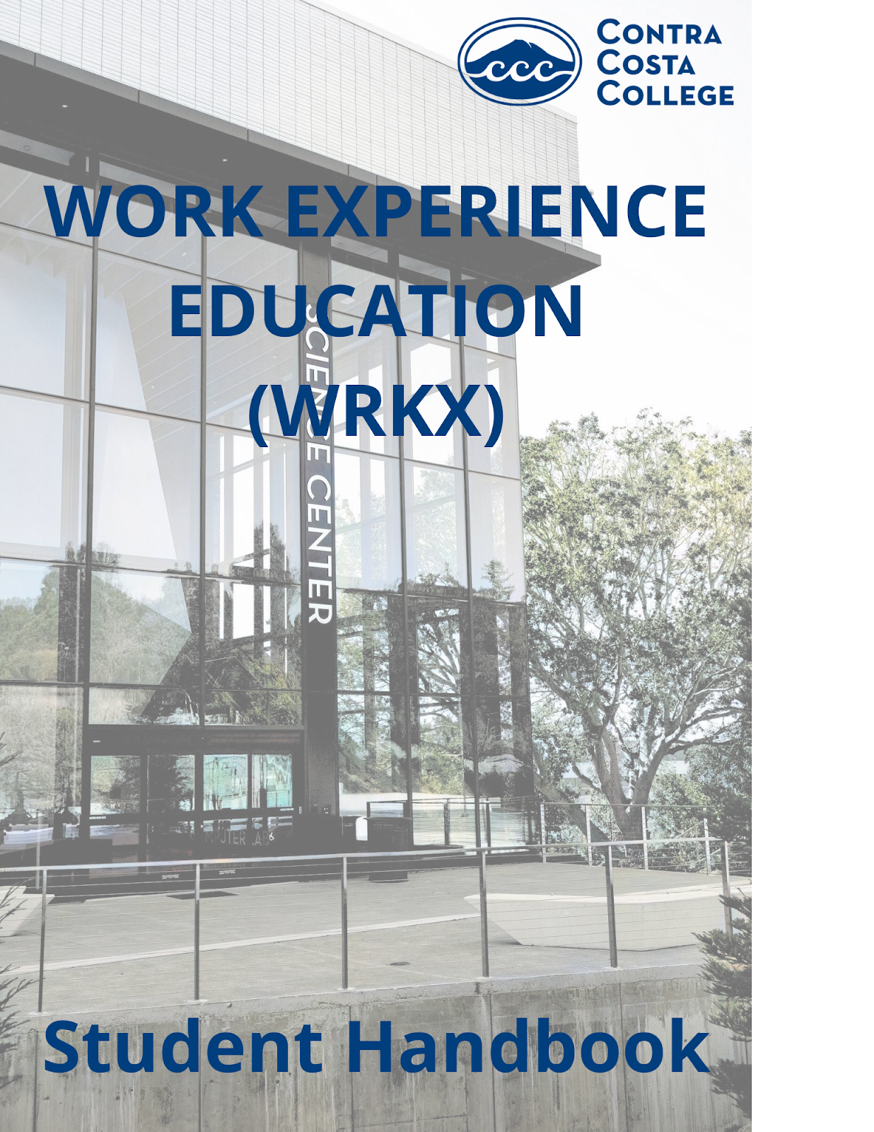

**WORK EXPERIENCE EDUCATION– OVERVIEW**

To complete registration for the course (and to remain enrolled) you must complete the following:

|  |  |
| --- | --- |
| **Employment/Volunteer** | Prior to enrollment in Work Experience Education (WRKX), you must already have employment, paid/unpaid internship, or enrolled in volunteer work with a supervisor. |
| **Register for Course** | 1. Prior to the term register through InSite or Admissions and Records 2. If the course has started, you may obtain permission to add from your instructor |
| **Complete Application** | Complete WRKX Application on college website or InSite email for link: [Work Experience Education - Contra Costa College](https://www.contracosta.edu/student-support/career-services/work-experience-education/) |
| **Create Learning Objectives** | Use “Work Experience Education (WRKX) Supervisor Agreement” to support conversations with your supervisor and complete the learning objectives together and sign. If you are enrolled in one unit complete one learning objective per unit registered. Your Objective Form will not be accepted if it is not signed by you and your supervisor |
| **Prepare & Attend Mandatory orientation** | Orientation is required to remain enrolled in the class. Bring the completed WRKX Learning Agreement (signed) to orientation. |
| **Complete Work Hours** | Ensure you are able to complete the total work hours for the units enrolled, (see hours chart below) If there is a change in work hours or jobs contact instructor. |
| **Worksite visit** | During the term your instructor will meet with your supervisor to get the grading on your Learning Objectives listed on the WRKX Learning Agreement. If the instructor has difficulty contacting your supervisor, you will be asked to assist in facilitating this meeting |
| **Final Paper - Learning Objective Essay** | Part of your final grade will include an essay on your learning objective. Your faculty will have details in their syllabus and during the orientation. |
| **Meeting and communicating with Instructor** | Communication will be facilitated through CANVAS, it is important to check for communication from your instructor. Your instructor will support you with appointments/questions. |

**PROGRAM GUIDELINES (FREQUENTLY ASKED QUESTIONS)**

**WHAT IS WORK EXPERIENCE EDUCATION (WRKX)?**

The Work Experience Education Program is designed to assist you with related work experiences whether as a paid employee, intern or community volunteer. The program involves students, faculty, and employers working together to enhance learning in your job.

Work Experience courses are listed in the catalog and class schedule as WRKX 170. Discipline specific courses are 099. Prior to enrollment in WRKX, you must already be employed, have an internship, or enrolled in volunteer work.

**Student Learning Outcomes (SLOs):** Students completing WRKX will be able to:

|  |  |
| --- | --- |
| * Improve capabilities on the job | * Conduct research |
| * Improve employability skills | * Develop professional behaviors |

**HOW CAN WRKX UNITS BE USED?**

* To meet financial aid, EOPS, athletic and other academic unit requirements
* The California State University system will accept Work Experience units as electives
* The University of California system typically will not accept Work Experience units
* Private universities or Colleges - Inquire about the policies regarding units as each institution may be different

**CAN I REPEAT WRKX CLASSES?**

Yes, WRKX 170can be taken multiple times.

Your Work Experience instructors will accurately record assignments and points accrued. Remember to contact your instructor throughout the term to stay on track and receive the maximum points. You may receive point deductions if you:

* Arrive late or miss appointments
* Turn in work late and/or miss assignments
* Do not complete the required hours of work

**REQUIRED WORK HOURS PER TERM**

**FALL / SPRING**

**(16-week Term)**

|  |  |  |
| --- | --- | --- |
| **Units** | **Average Hours Per Week** | **Total Semester Hours** |
| 1 | 3 | 54 |
| 2 | 7 | 108 |
| 3 | 11 | 162 |
| 4 | 13.5 | 216 |

**SUMMER**

**(4 Week)**

|  |  |  |
| --- | --- | --- |
| **Units** | **Average Hours Per Week** | **Total Semester Hours** |
| 1 | 13.5 | 54 |
| 2 | 27 | 108 |
| 3 | 40.5 | 162 |

### What is an Objective?

**TIPS FOR WRITING A LEARNING OBJECTIVE**

Objectives establish goals for the course, tailored to the needs of each student and employer.

### Objectives must address:

* What is the task to be accomplished?
* How will it be accomplished?
* How will it be evaluated (measured) and by whom?
* When will it be accomplished?

### S - Specific M - Measurable A- Attainable R- Relevant T- Time BasedSteps to Writing SMART Objectives:

**Specific** – Describe a precise or specific outcome.

**Measurable** – Describe the system you’ll put in place to measure your progress.

**Action-Oriented** – Describe the specific actions you will take to accomplish the objective.

**Relevant** – Can you make an impact on the situation? Is it important to your education?

**Time-Based** – Clearly define your completion date.

### Consider an objective that shows level of:

**Creativity:** Doing things a new way or finding new things to do on the job.

***Example:*** Designing a new system for tracking customer inquiries.

**Problem Solving:** Identifying a problem and finding a reasonable solution.

***Example:*** Customers complain about long lines at your store. You determine a method to speed-up check-out.

**Skill development:** Seek opportunity to improve your effectiveness on the job ***Example:*** You work in the stockroom but want to move into sales. You seek training from your supervisor to learn effective sales associate skills

### Questions to ask yourself:

* Is there anything I could do to help improve the day-to-day aspects of my job? How?
* How will it be measured (observation, a report, etc.)?
* Are there specific problems in my work area? How might I solve them?
* Is there anything I would like to learn in my current job? Is there anything my manager does that I would like to learn how to do?
* Do I need to improve my basic skills in any area of my job?

**STUDENT LEARNING OBJECTIVES – EXAMPLES**

## EXAMPLE OBJECTIVE #1

**What is the task to be completed?** Improve and rebuild a better procedures handbook for volunteers.

**How will it be accomplished**: Observing volunteers, removing old documents and creating new procedures.

**How will it be measured?** To be submitted to supervisor for evaluation.

**When will be completed?** *By the end of October*.

## EXAMPLE OBJECTIVE #2

**What is the task to be completed?** Learn how to upload patient chart information to the computer.

**How will it be accomplished?** My supervisor will train me how to input patient information in the computer.

**How will it be measured?** I will be able to upload patient charts without any help.

**When will it be completed?** By the end of the spring term.

## EXAMPLE OBJECTIVE #3:

**What is the task to be completed?** Learn how to process supplies and shipping invoices of company bills.

**How will it be accomplished?** Through instruction and on-the-job training in invoice control. **How will it be measured?** Supervisor will evaluate my performance at the end of the term. **When will it be completed?** Two weeks after final training.

**OBJECTIVES PRACTICE**

**OBJECTIVE #1**

**What is the task to be completed?**

**How will it be accomplished?**

**How will it be measured?**

**When will it be completed?**

## OBJECTIVE #2

**What is the task to be completed?**

**How will it be accomplished?**

**How will it be measured?**

**When will it be completed?**

**LEARNING OBJECTIVE REPORT GUIDELINES**

**LEARNING OBJECTIVE REPORT GUIDELINES**

Learning Objective Reports are due at or before the final conference with your instructor. Specific due dates are determined by your WRKX instructor.

Learning Objective Reports must be in essay format, typed, double-spaced, 12-point font, and a minimum of two-three (2-3) pages in length (approximately 1 page per objective).

### In addition to the minimum 2-3 page report, please include a cover sheet with:

* Your name
* Name of Company/Organization, Job Title
* WRKX Education course and section number
* Term for which you are enrolled
* Name of your assigned WRKX Education instructor

The theme of your paper is a discussion of the learning objectives you developed at the beginning of the term and how they were achieved. This is an integral part of the learning process and should be written as such. Your paper should show reflection, insights, new learning, and thoroughly address the following topics.

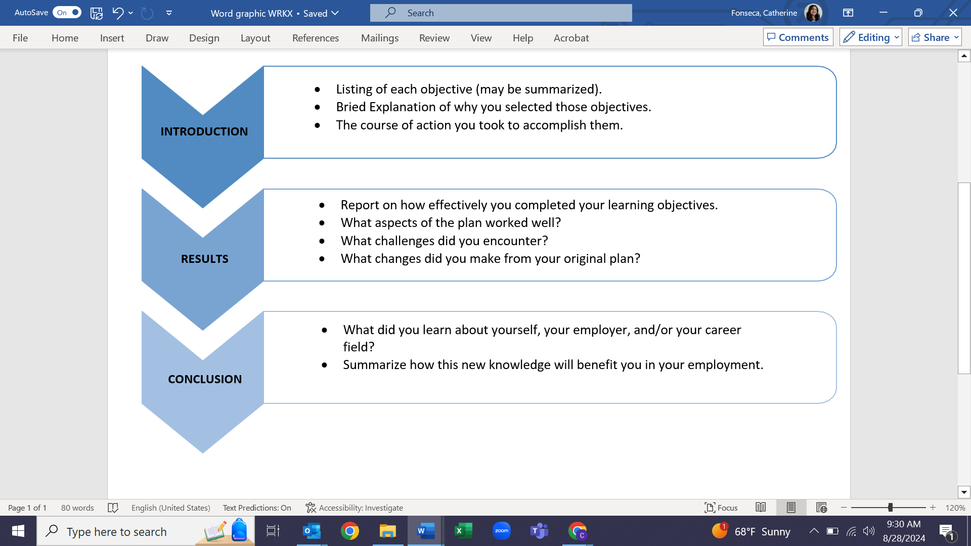

  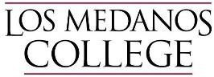

**WORK EXPERIENCE EDUCATION (WRKX) SUPERVISOR AGREEMENT**

|  |  |  |
| --- | --- | --- |
| **Student Name:** | **Student ID #** | **Course/Section #** |

|  |  |
| --- | --- |
| Thank you for supporting and supervising a WRKX student. The WRKX program is designed to help students prepare for career success by improving communication skills, setting major or career-related goals that are evaluated by a supervisor, and learning more about navigating the world of work. Your participation will help this student on the road to their career. If you have any questions, please reach out to the WRXK contact at the bottom of this agreement. Please review the supervisor agreement.  I understand the above student is enrolled in Work Experience Education (WRKX) and I, as the supervisor, agree to participate in the following ways:   * Identify measurable objectives the student will work on over the term using the WRKX Learning Agreement. * Evaluate the student's progress toward the agreed-upon learning objectives. * Meet with the student regularly to provide feedback (at least twice during the term). * Verify the total number of hours worked by signing the timesheet. * Verify the total number of hours worked by signing the timesheet.   I understand the instructor will award academic credit for successful completion of the objectives. The work experience must in some way align with the student’s career goals, even if the job/volunteer experience is not in the student’s major or career path.  The Contra Costa Community College District (4CD) does not discriminate on the basis of race, national origin, sex, color, religion, age, or disability in employment, educational programs, and activities.  Employers who sign this contract are expected to uphold this policy in their selection of prospects for employment, educational processes, or activities. It is understood that 4CD will provide Worker’s Compensation for UNPAID internships and/or liability insurance as required by law. | |
| **Supervisor Signature:**  **Student Signature: Instructor Signature:** | **Date:** |
| **Date:** |
| **Date:** |

  

**WORK EXPERIENCE EDUCATION (WRKX) LEARNING AGREEMENT**

|  |  |  |  |  |
| --- | --- | --- | --- | --- |
| **Student Name:** |  | **Student ID#: Student Phone #: Worksite Address:** | | **Course Section #**: |
| **Student Email:** |  |  |
| **Worksite Name:** |  |  |
| **Supervisor:** |  | **Email:** |  | **Phone:** |

New learning objectives are required each term that a student is enrolled in WRKX. (54 working hours = 1 unit= 1 objective). Learning objectives reﬂecting new or expanded job-related responsibilities must be written by the student and approved by the supervisor and instructor at the beginning of the term. The objective(s) must in some way align with the student's career goal or major, be substantive, measurable, and attainable. *Be creative*. There

are many skills to be learned or improved even if the work experience is not exactly within the major. The supervisor will meet with the instructor at least once during the term to evaluate the student’s performance on their learning objectives, and the Instructor will award academic credit for successful completion of the program requirements.

|  |  |  |
| --- | --- | --- |
| **STUDENT LEARNING AGREEMENT (STUDENT/EMPLOYMENT SUPERVISOR COMPLETE)** | | **Supervisor Score Out of 100** |
| 1 | By the end of the term, I will learn and/or improve: |  |
|  |  |
|  |  |
| 2 | By the end of the term, I will learn and/or improve: |  |
|  |  |
|  |  |
| 3 | By the end of the term, I will learn and/or improve: |  |
|  |  |
|  |  |
| 4 | By the end of the term, I will learn and/or improve: |  |
|  |  |
|  |  |

|  |  |
| --- | --- |
| **Supervisor Signature:** | **Date:** |
| **Student Signature:** | **Date:** |
| **Instructor Signature:** | **Date:** |

|  |  |  |  |  |
| --- | --- | --- | --- | --- |
| **END-OF-TERM EVALUATION – INSTRUCTOR USE ONLY** | | | | |
| Course Units: Final Grade: Paid: Unpaid: Course Hours Total: | | | | |
| **Contact with Supervisor:** | 1st Contact | Date: | 2nd Second Contact | Date: |
| **Visitation of worksite by instructor** | Yes No | Date: |  |  |
| **Personal Consultation(s) with Student** | Yes No | Date: |  |  |
| ***Final Supervisor Signature*** |  | ***Date:*** | ***Average Hrs. Weekly:*** | |
| ***Final Instructor Signature:*** |  | ***Date:*** |  | |